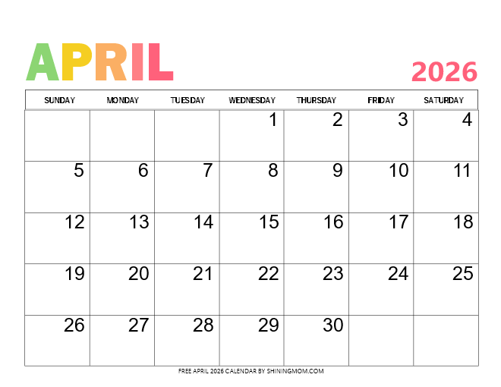
BEGINNER SHUFFLE BOARD 9:00
BEGINNER SHUFFLE BOARD 9:00
BEGINNER SHUFFLE BOARD 9:00
MAH JONG
BEGINNER 1:00

MAH JONG
BEGINNER 1:00
TRIVIA
CRIB
1:00

BRIDGE
1:00
BRIDGE
CRIB
1:00

BEGINNER CALENDAR
MAH JONG
BEGINNER 1:00

MAH JONG
BEGINNER 1:00
BRIDGE
1:00
BRIDGE
1:00
BEGINNER SHUFFLE BOARD 9:00

